Theme: Advancing Pharmaceutics: From Formulation to Patient Impact
13
th
Edition of Global
Conference on
Pharmaceutics and
Novel Drug Delivery
Systems
14-16
SEPTEMBER 2026
Rome, Italy
HYBRID EVENT
Come and Join us in: Rome, Italy or Virtually
BROCHURE
For More Info:
CONTACT US
+1 (702) 988 2320
+1 (640) 666-9566 https://x.com/Pharma_PDDS pharma@magnusconference.com
https://pharmaceuticsconference.com/ https://www.facebook.com/PharmaGlobalConference/
Cellular Targeting and Intracellular Delivery
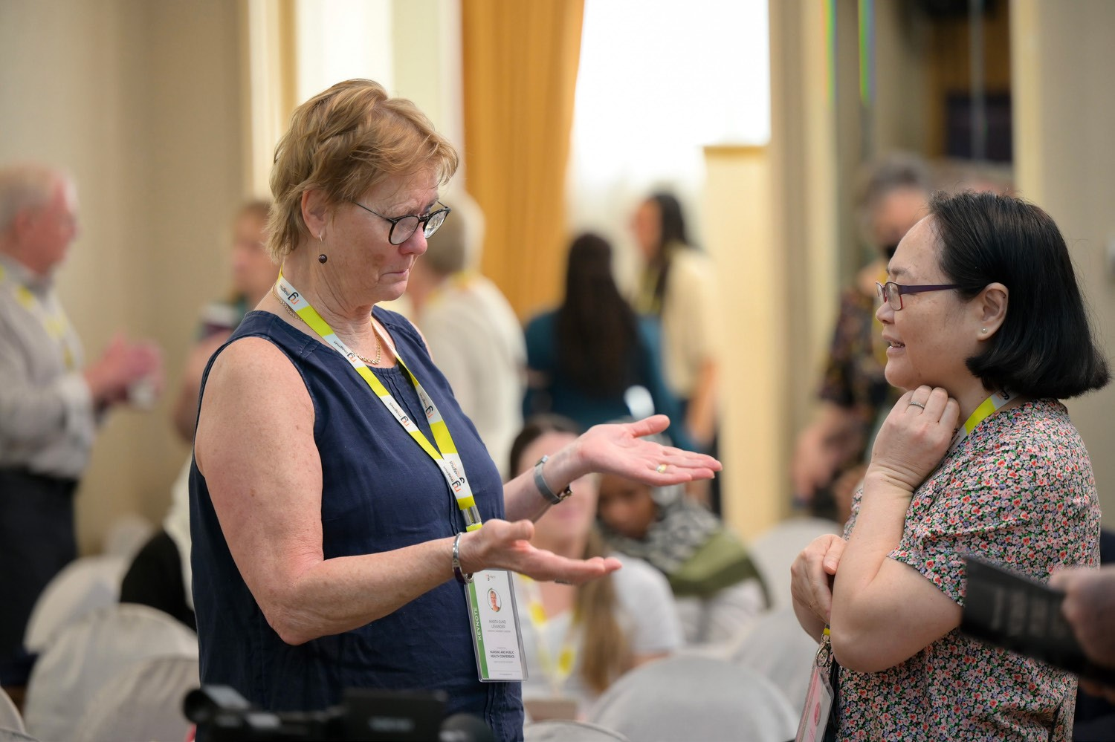
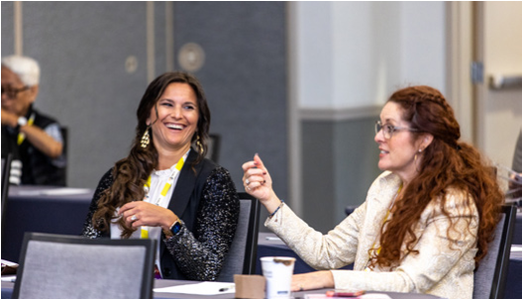
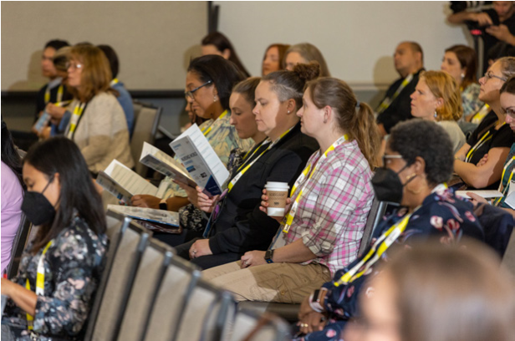
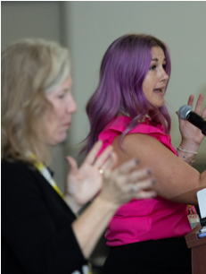

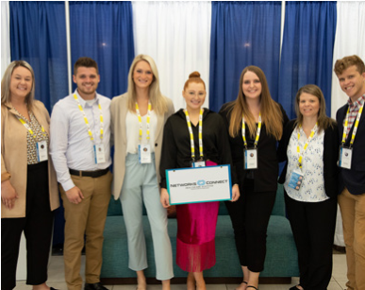
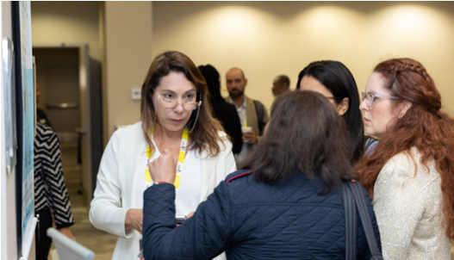
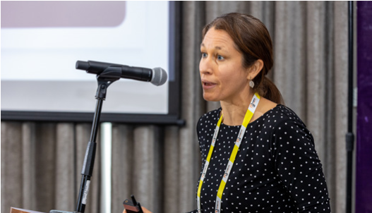
Pharmaceutical Microbiology and Biotechnology
•
Novel Developments In Drug Delivery System
•
•
•
•
Pharmaceutical Product Development and Manufacturing
•
Advanced Drug Delivery Systems
•
Vaccine Design and Drug Delivery Technology
•
Pharmacovigilance and Drug Safety
•
Pharmacogenomics
•
Therapeutic Drug Carrier Systems
•
Regulatory Affairs and Intellectual Property Rights
•
Nanotechnology in Pharmaceutics and Drug Delivery Systems
•
Clinical and Medical Case Reports
•
Pharmaceutical Analysis
•
Personalized and Precision Medicine
For Scientific Sessions See:
https://pharmaceuticsconference.com/program/scientific-session
s
Develop Your Network
Position Yourself as an Expert
Meet Experts & Influencers Face to Face
Gain Targeted Knowledge
New Tips & Tactics
Invest In Yourself
Gain New Collaborations
Present your Ideas and Work
Be Inspired
Travel, Explore and Have Fun!!
For Abstract Submission See:
t
https://pharmaceuticsconference.com/submit-abstrac
ABOUT PDDS 2026
CONFERENCE TOPICS
REASONS TO ATTEND
Magnus Group is delighted to announce the
13
th Edition of the Global
Conference on Pharmaceutics and Drug Delivery Systems (PDDS
2026)
,
taking place
September 14–16, 2026
. This innovative hybrid
event offers participants the choice of joining in person in
Rome, Italy,
or
virtually
from anywhere in the world, bringing together a vibrant
community of pharmaceutical professionals, researchers, scientists, and
industry leaders.
Under the theme
“Advancing Pharmaceutics: From Formulation to
Patient Impact” PDDS 2026
underscores its dedication to addressing
global challenges and advancing scientific innovation in the field. The hybrid
format ensures a dynamic, inclusive experience that welcomes and engages
attendees across the globe.
To know Complete Details Visit:
/
https://pharmaceuticsconference.com
Formulation Technologies





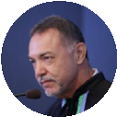

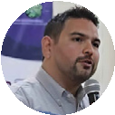
CONFERENCE SCHEDULE
DAY 01
MONDAY
SEPTEMBER 14, 2026
08:00-09:00
Registrations
09:00-09:30
Opening Ceremony
and Introduction
09:30-10:30
Keynote Session I
10:30-11:00
Refreshment Break
11:00-12:30
Keynote Session II
12:30-13:30
Lunch
13:30-15:00
Break Out Session I
15:00-15:30
Refreshment Break
15:30-18:00
Break Out Session II
TUESDAY
SEPTEMBER 15, 2026
DAY 02
09:00-10:30
Keynote Session III
10:30-11:00
Refreshment Break
11:00-12:30
Break Out Session III
12:30-13:30
Lunch
13:30 15:00
Poster Presentations
15:00-15:30
Refreshment Break
15:30-18:30
Break Out Session IV
WEDNESDAY
SEPTEMBER 16, 2026
DAY 03
09:00-10:30
Keynote Session IV
10:30-11:00
Refreshment Break
11:00-12:30
Break Out Session V
12:30-13:30
Lunch
13:30-15:00
Break Out Session VI
15:00-15:30
End Note Session and
closing ceremony
OUR KEYNOTE SPEAKERS
Vladlen Slepak
University of Miami Miller School of Medicine,
United States
Yong Xiao Wang
Albany Medical College,
United States
Consolato M Sergi
Universities of Alberta and Ottawa,
Canada
Saad Tayyab
UCSI University,
Malaysia
Paulo Cesar De Morais
Catholic University of Brasilia,
Brazil
Sergey Suchkov
N.D. Zelinskii Institute for Organic Chemistry of
the Russian Academy of Sciences & InMedStar,
Russian Federation
Luis Jesus Villarreal Gomez
FCITEC - Universidad Autónoma de Baja California,
Mexico
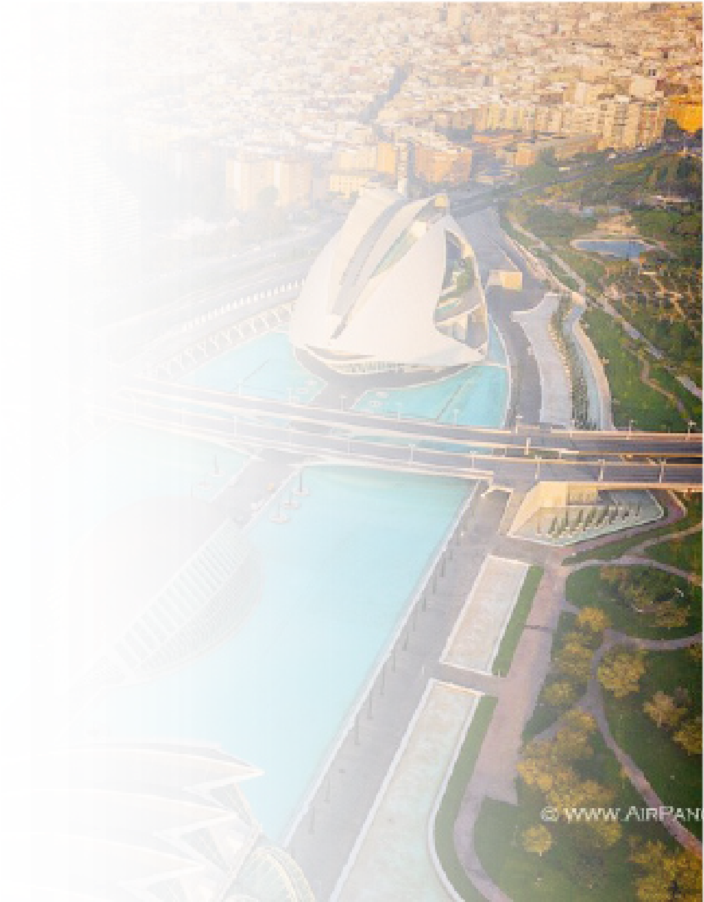
REGISTRATION
INCLUDES
For In-person Participants:
•
Access (Entry) to all conference sessions, poster
presentations
•
Conference kit including name tag, program
booklet and Abstract Book
•
2
Coffee breaks and Lunch for all the conference
days
•
Certificate accreditation from Organizing
Committee
For Virtual Participants:
•
Access to all Presentations
•
E-Abstract Book and Program
•
E-Certificate for Presentation and Participation
HOW TO REGISTER
In order to register for PDDS 2026, please complete the online
form available on:
https://pharmaceuticsconference.com/registe
r
You are kindly invited to submit your abstract for PDDS 2026
Online Abstract Submission:
https://pharmaceuticsconference.com/submit-abstrac
t
Questions regarding Abstract Submission Contact us:
pharma@magnusconference.com
ABSTRACT SUBMISSION
CONFERENCE REGISTRATION
Presenter
$739 (In-Person)
Presenter
$439 (Virtual)
Listener
$839 (In-Person)
Listener
$539 (Virtual)
Conference and Accommodation Venue:
NH Villa Carpegna
Via Pio IV, 6, 00165 Roma RM, Italy
If you’d like to secure accommodation at the conference venue, please select
your preferred dates and make your reservation using the link provided
below.
Please select and book preferred accommodation online on
our website:

https://pharmaceuticsconference.com/register
Organizer:
Magnus Group LLC
150
South Wacker Drive #2400, Chicago, IL 60606, USA
Website: https://www.magnusgroup.org/

